*Group Members:*

*Reema Albouainain (202103056)  
Fatima Almohannadi (202002307)  
Shatha Alhazbi (202108114)*

*Web development fundamentals project*

***PHASE 1***

**Table of Contents**

**Phase 1**

|  |  |
| --- | --- |
| **Titles** | **Page no.** |
| Class diagram + GitHub link | 2 |
| Screenshots of website | 3-15 |

**Github repo link:**

**Class diagram:**

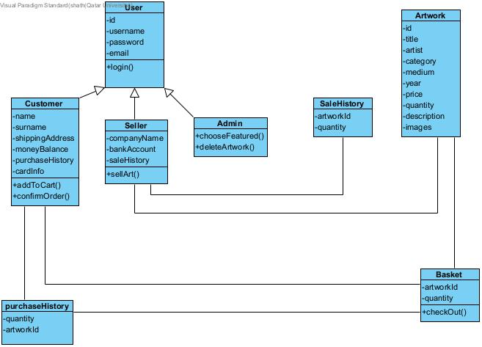

**Main page** 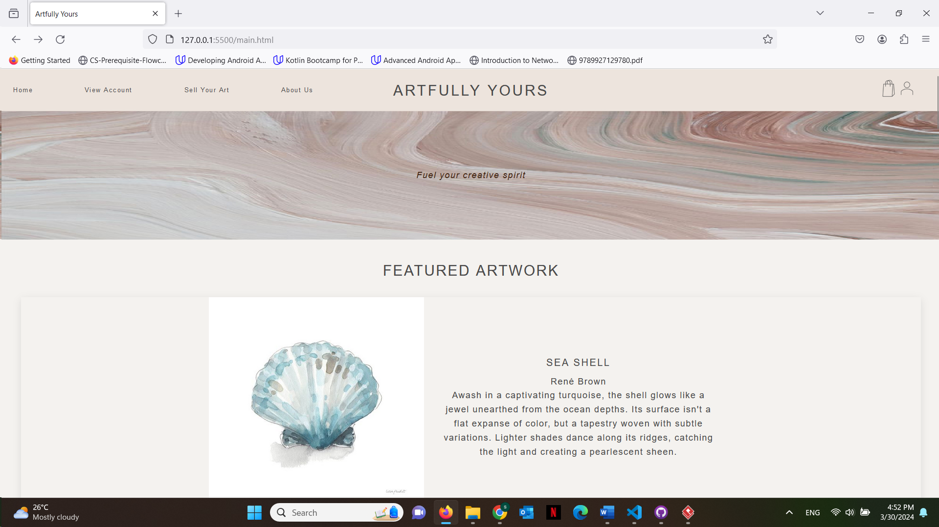

**Login page (logging in as admin user now)**

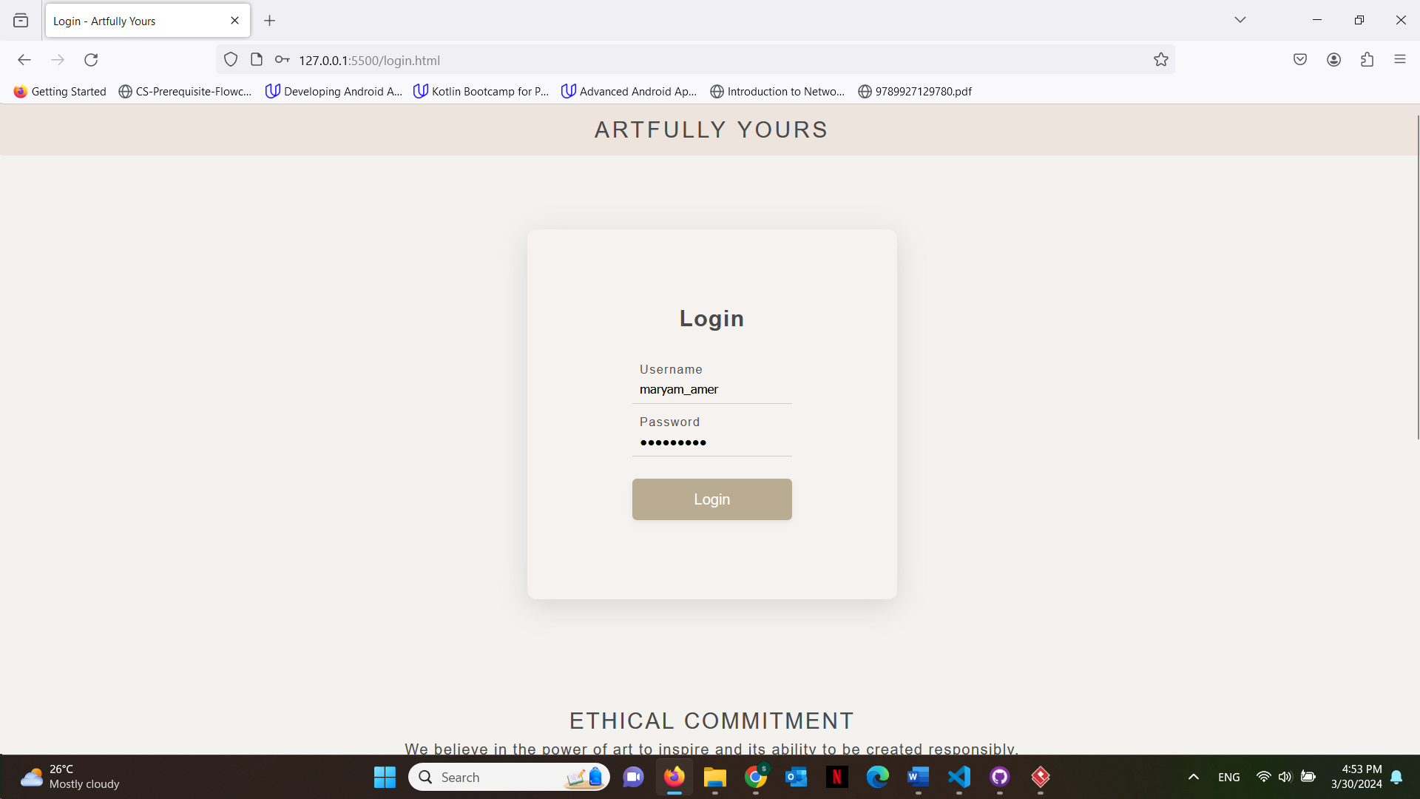

**Admin can choose to change the featured artwork**

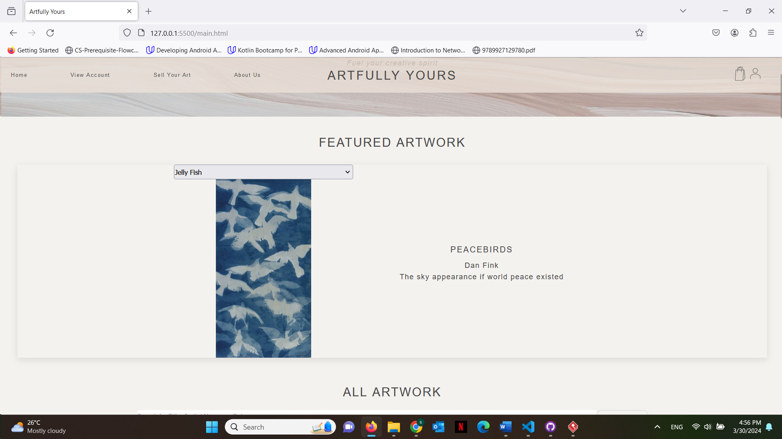

**Admin can also delete current art being sold**

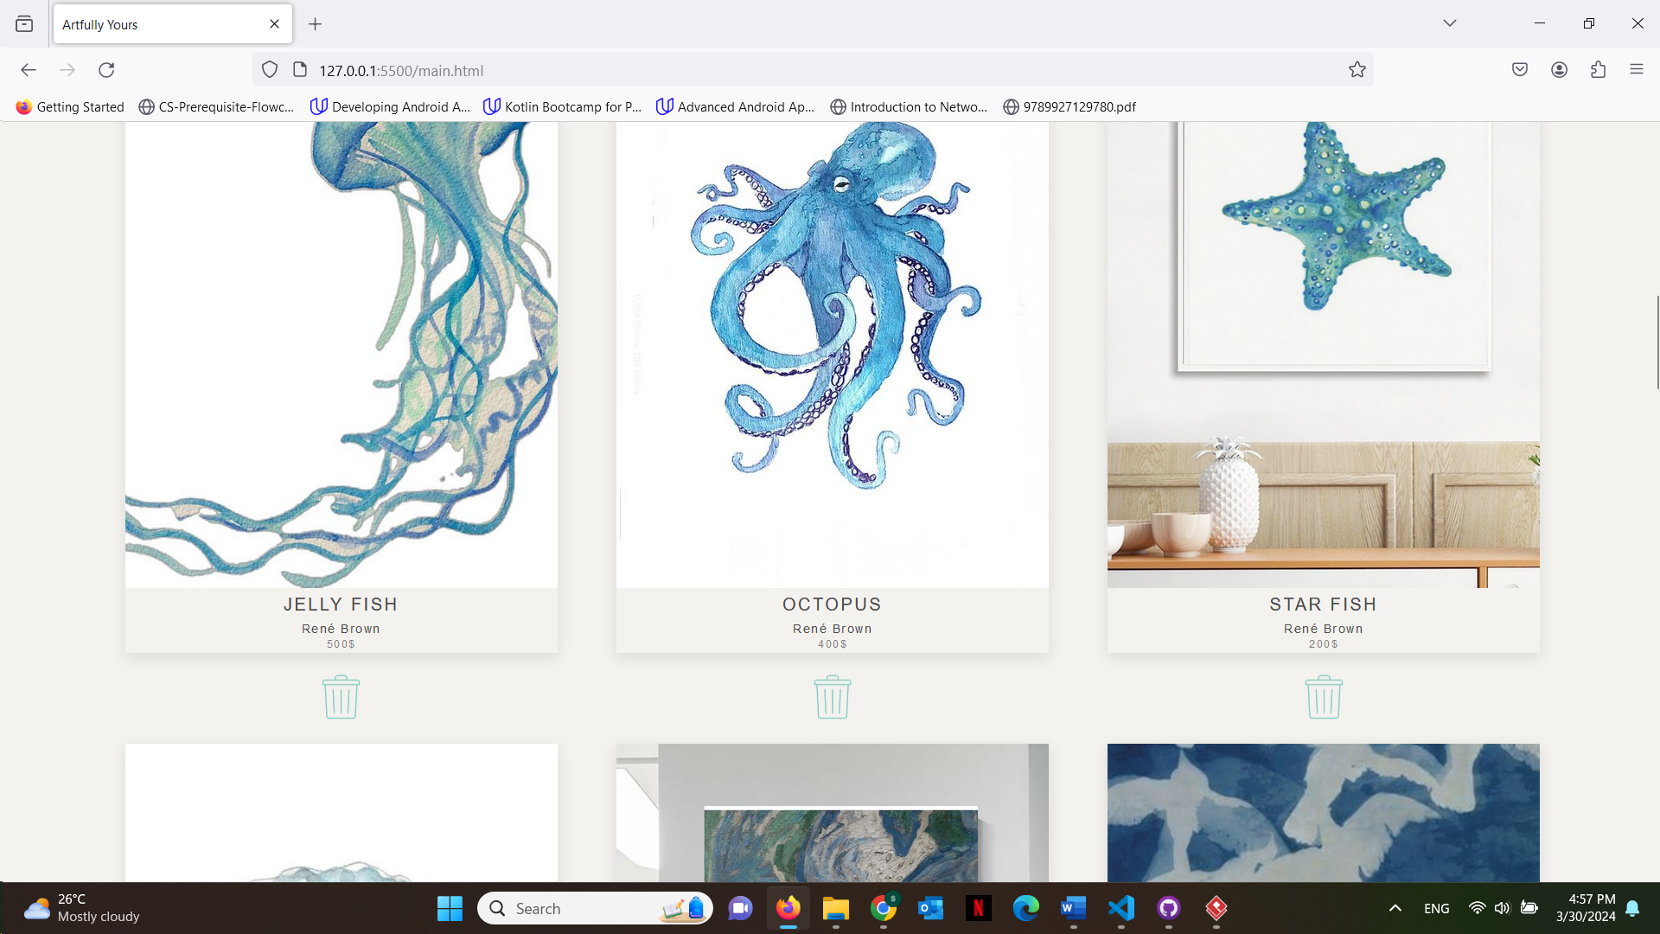

**Now logged in as customer we can see the new featured artwork has changed than the first time** 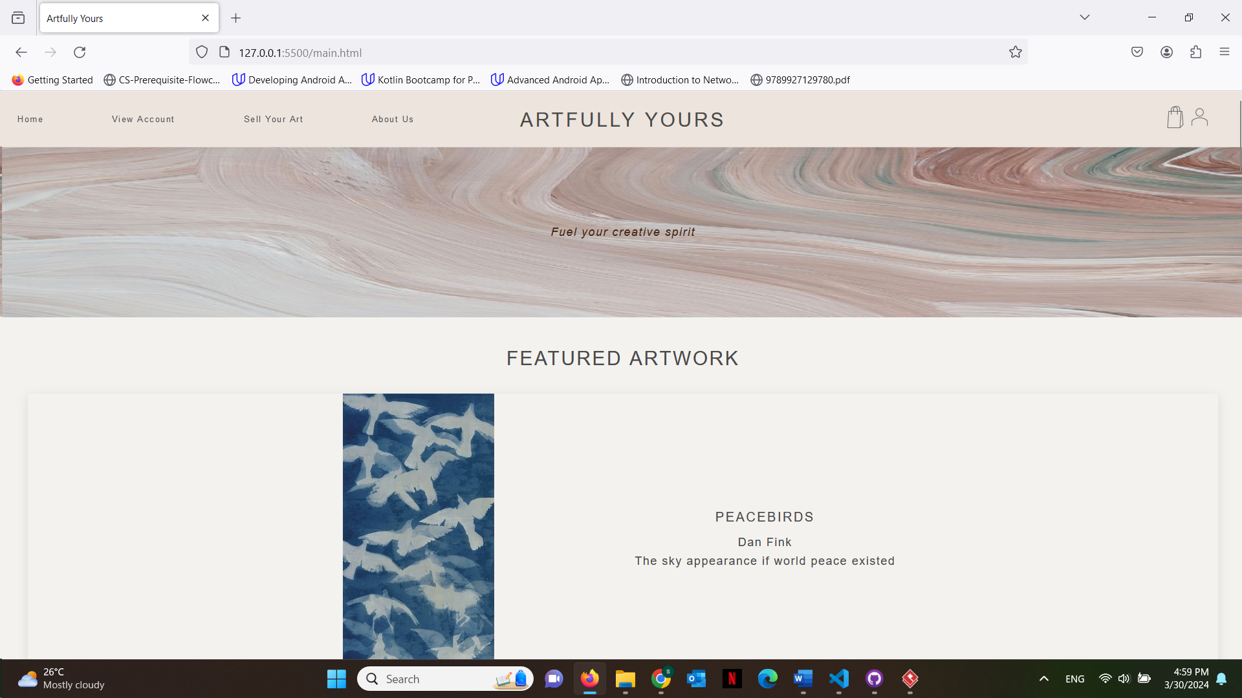

**When customer hovers over a certain artwork, add to cart button shows up and they can press it and get an alert that artwork has been added to their basket**

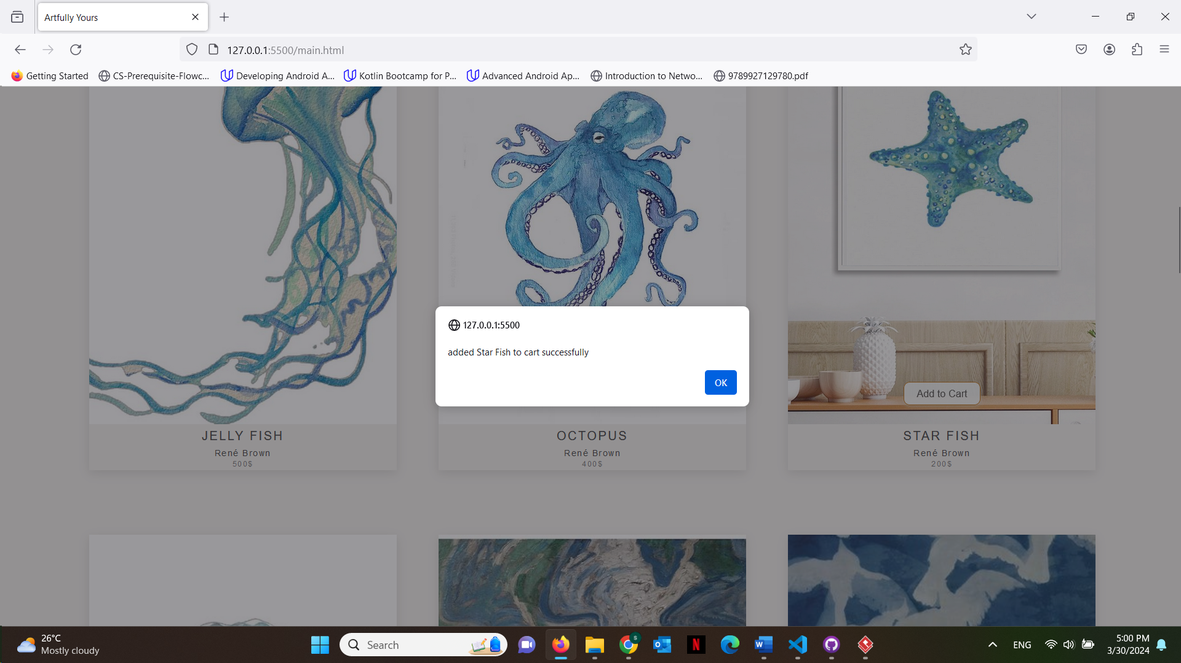

**Customer can check their basket and edit the quantities there**

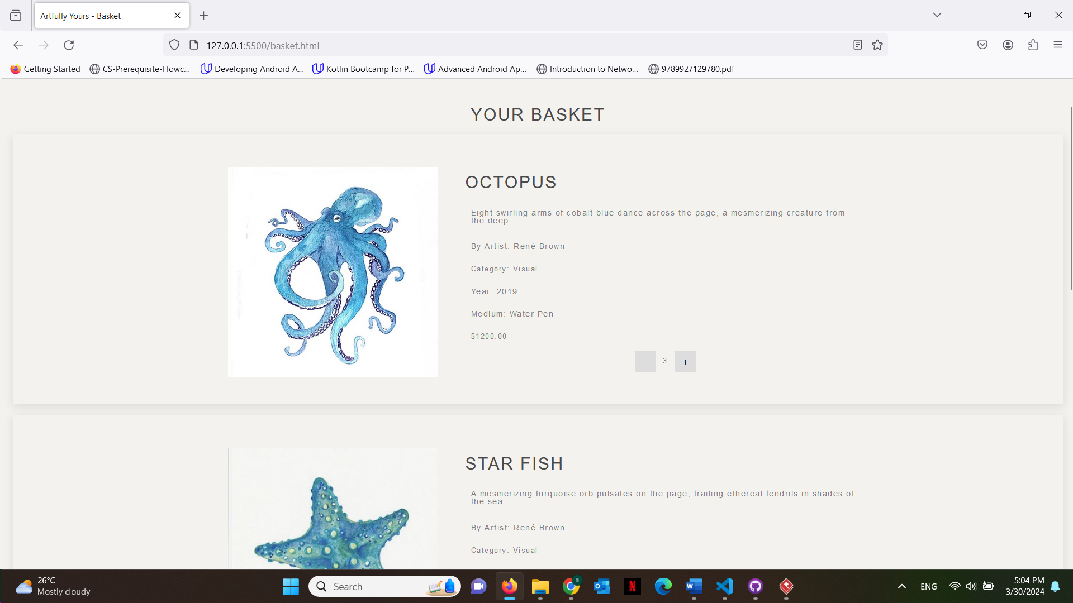

**If they try to buy more than what is available, they get an alert**

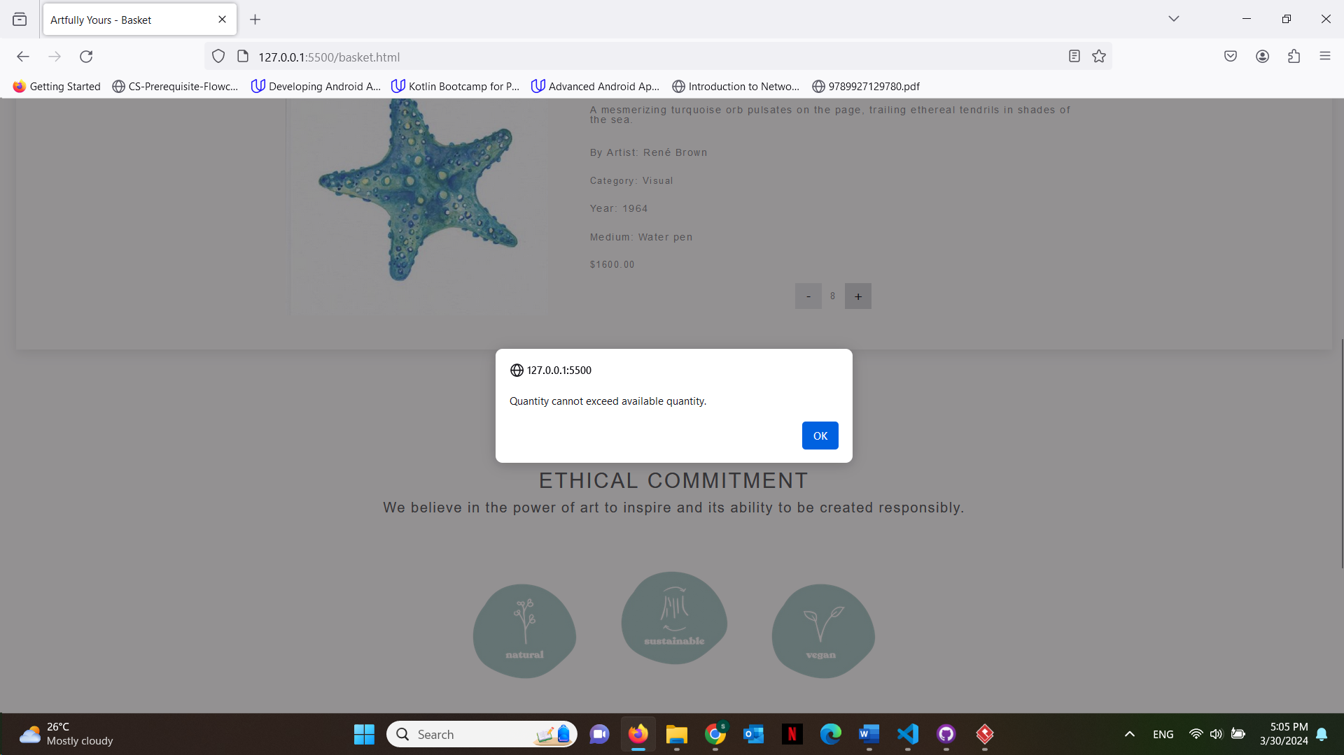

**Once the user presses check out button it will take them to the checkout page to enter their details**

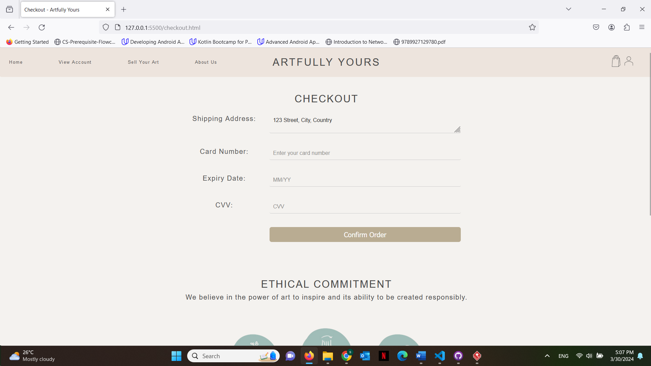

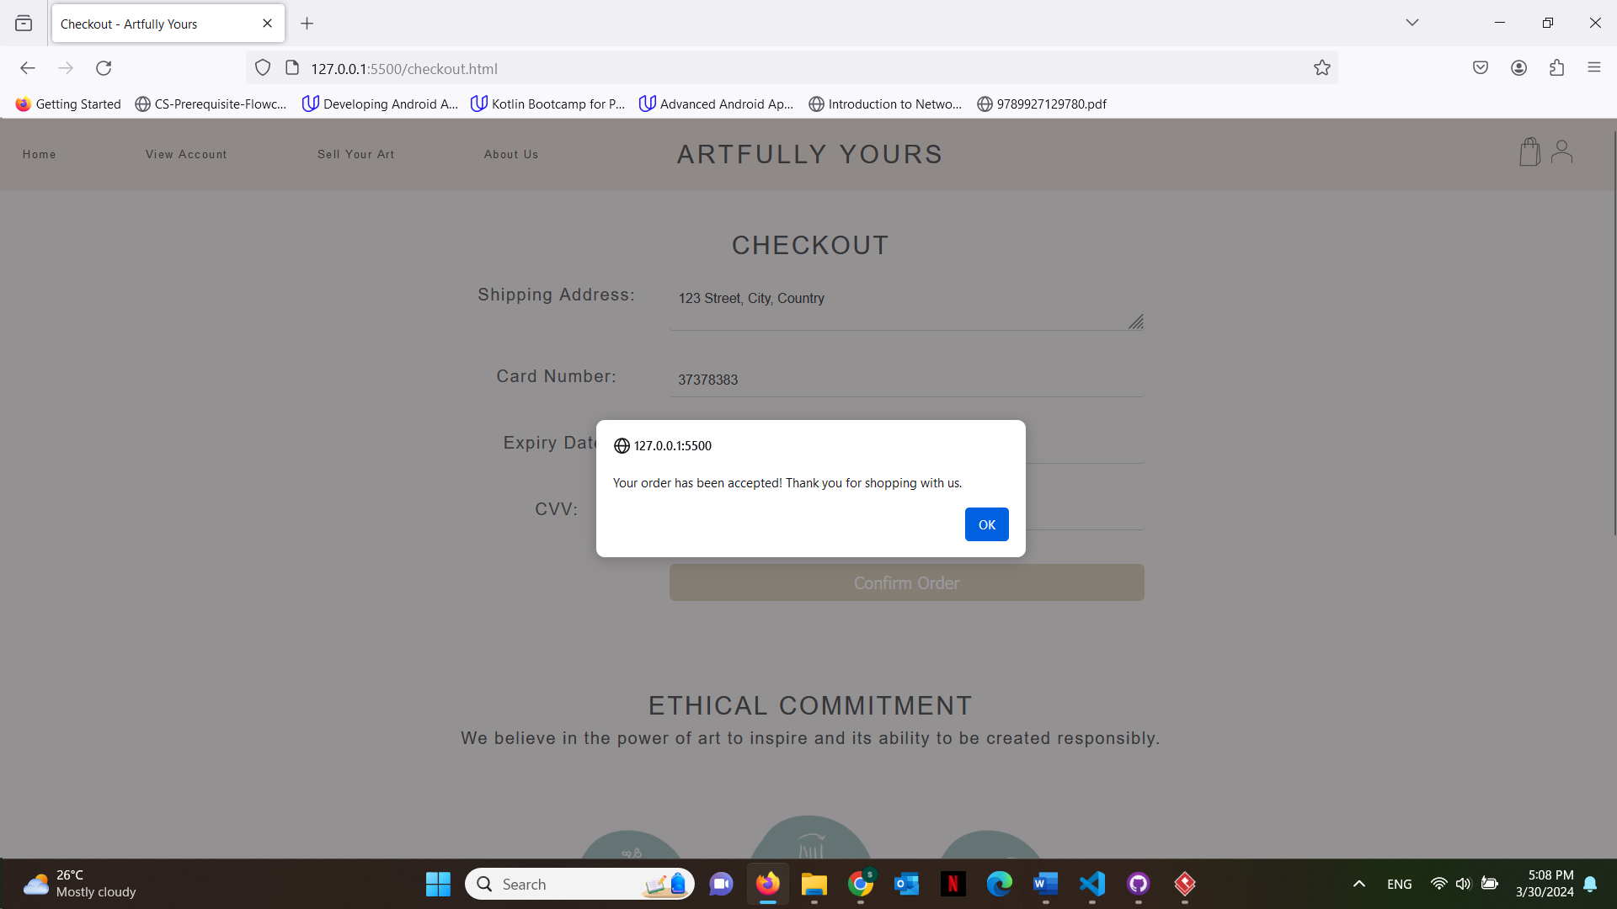

**Now once they go to view account they will see the purchase history**

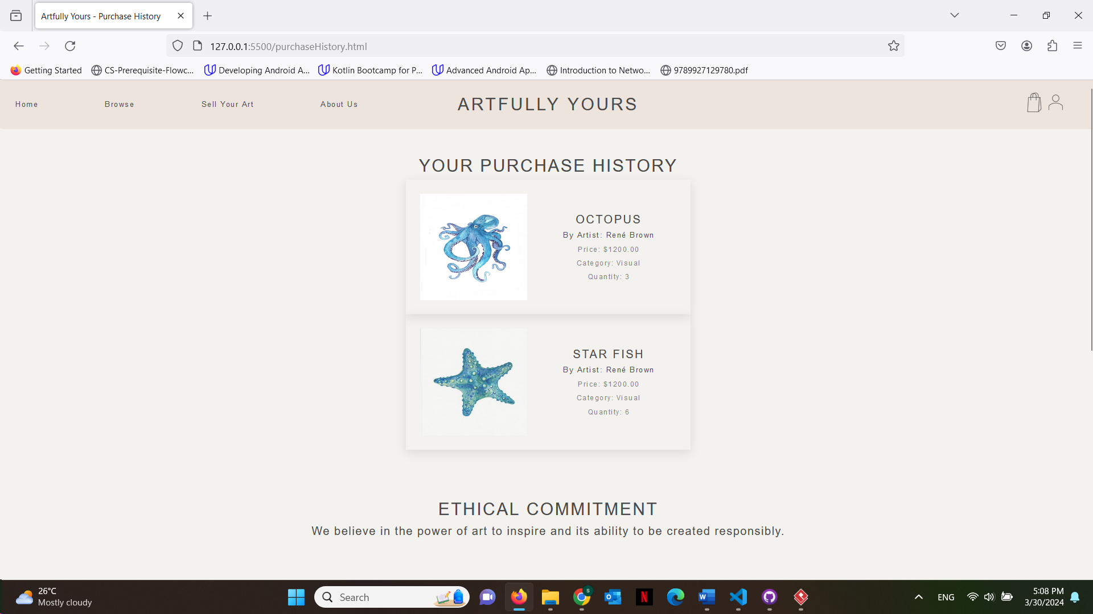

**Trying to buy another artwork**

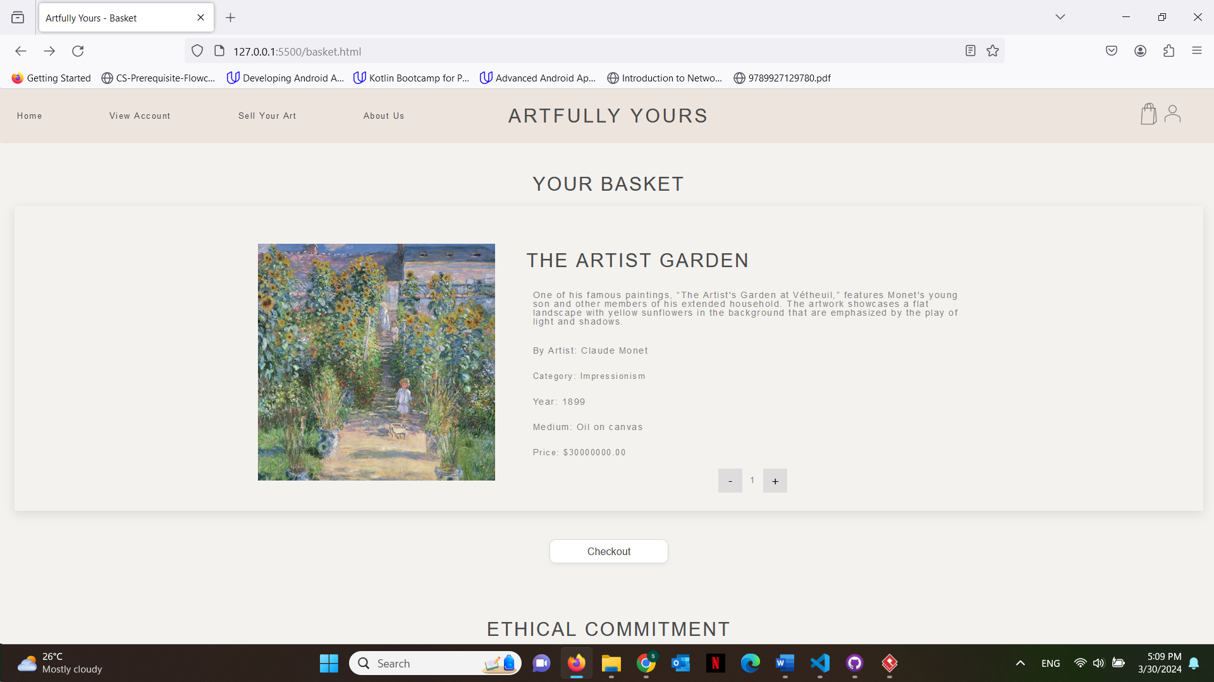

**This time the user details will be displayed already as they got saved**

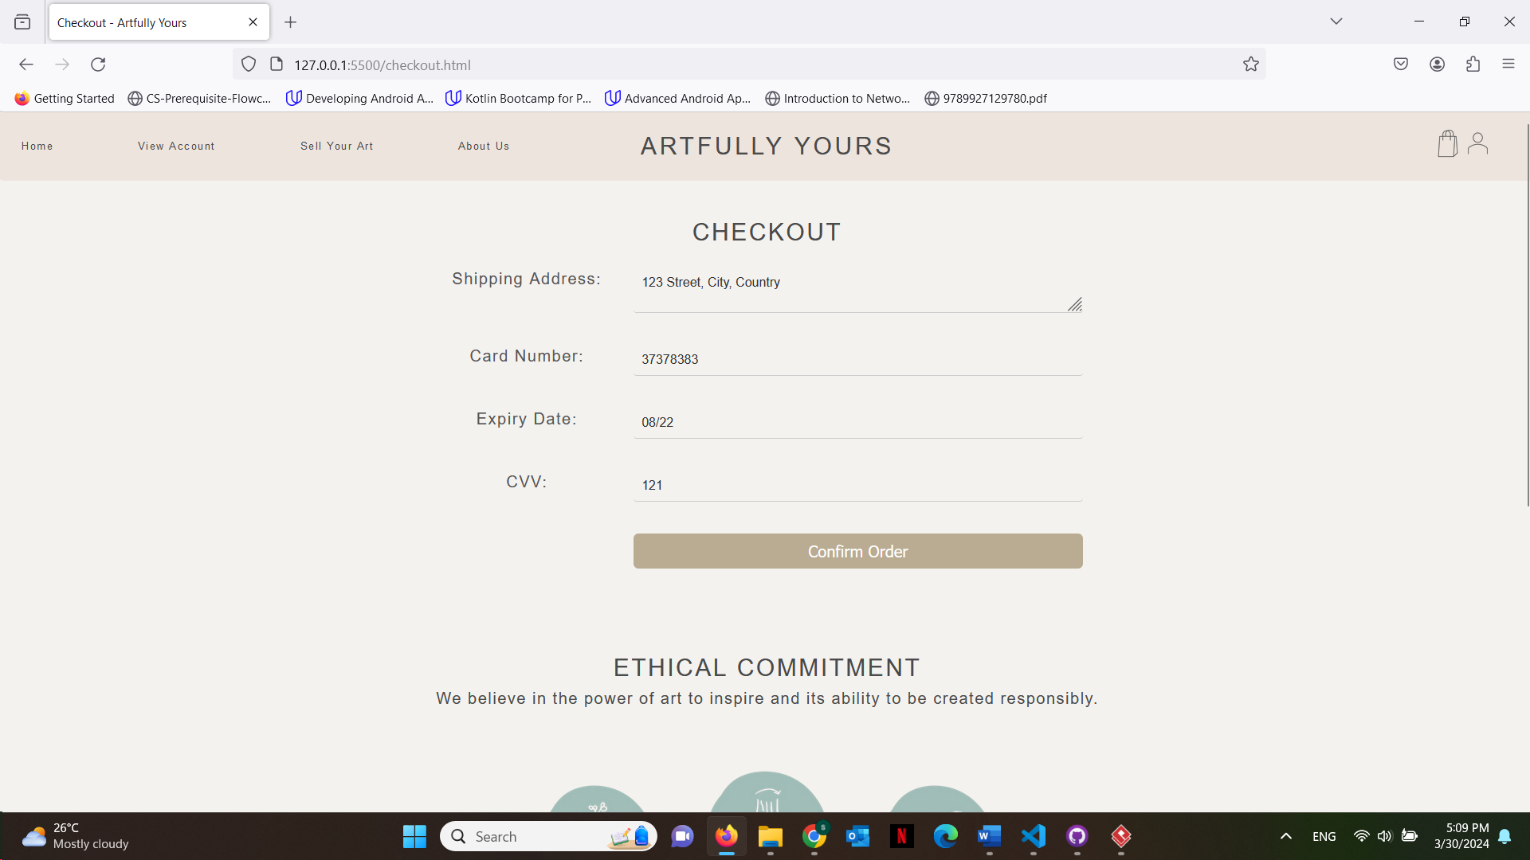

**Once the customer tries to confirm order but they do not have enough balance they get an alert**

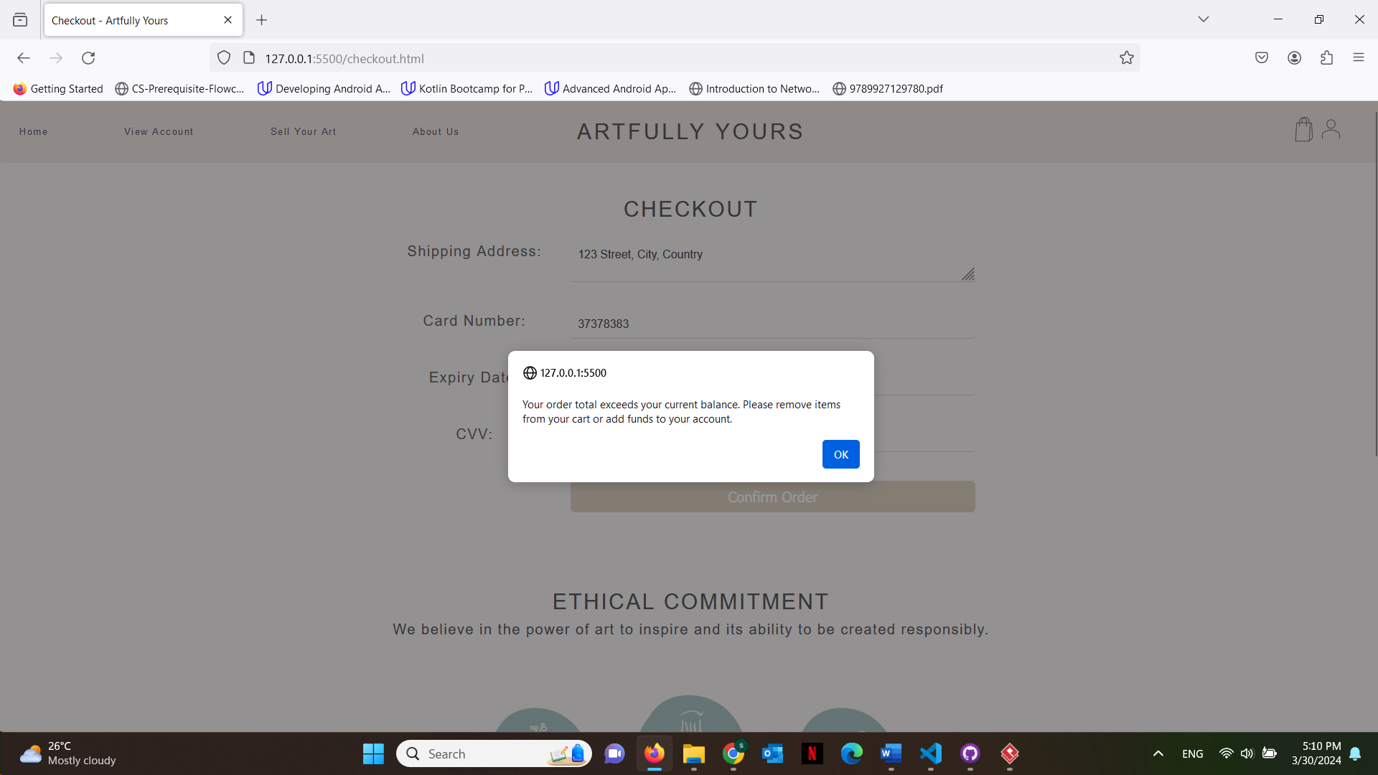

**Every time a user buys an artwork, the artwork quantity decreases so if it reaches 0 and a user tries to add to cart they get an alert**

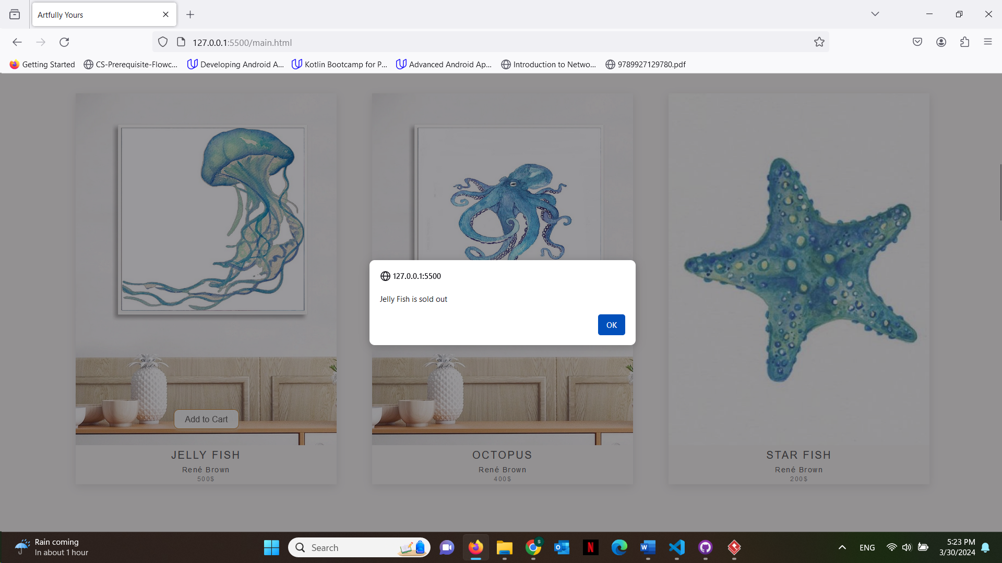

**Now logged in as a seller, once view account is pressed they will be able to see the sale history**

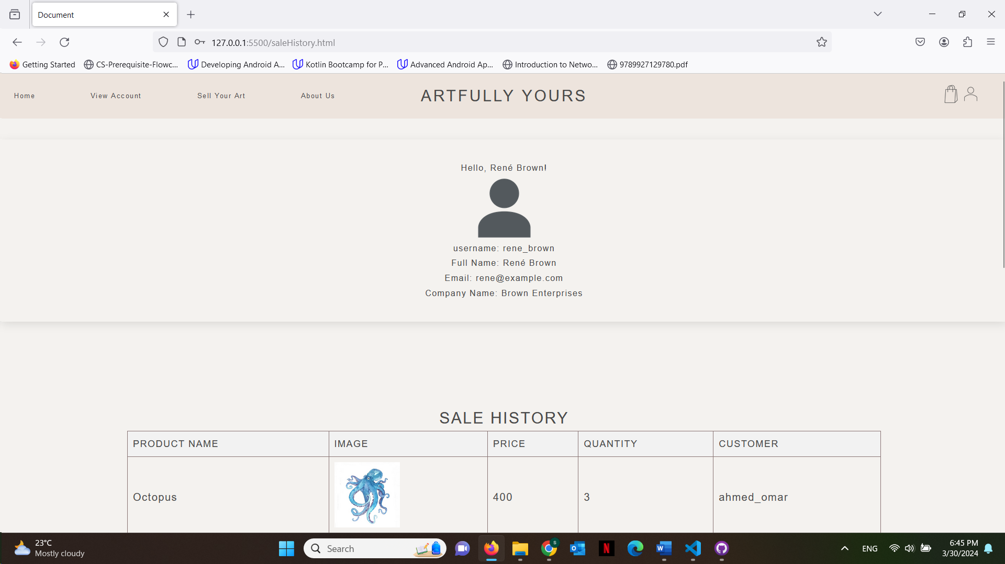

This is what the last customer bought as we just saw.

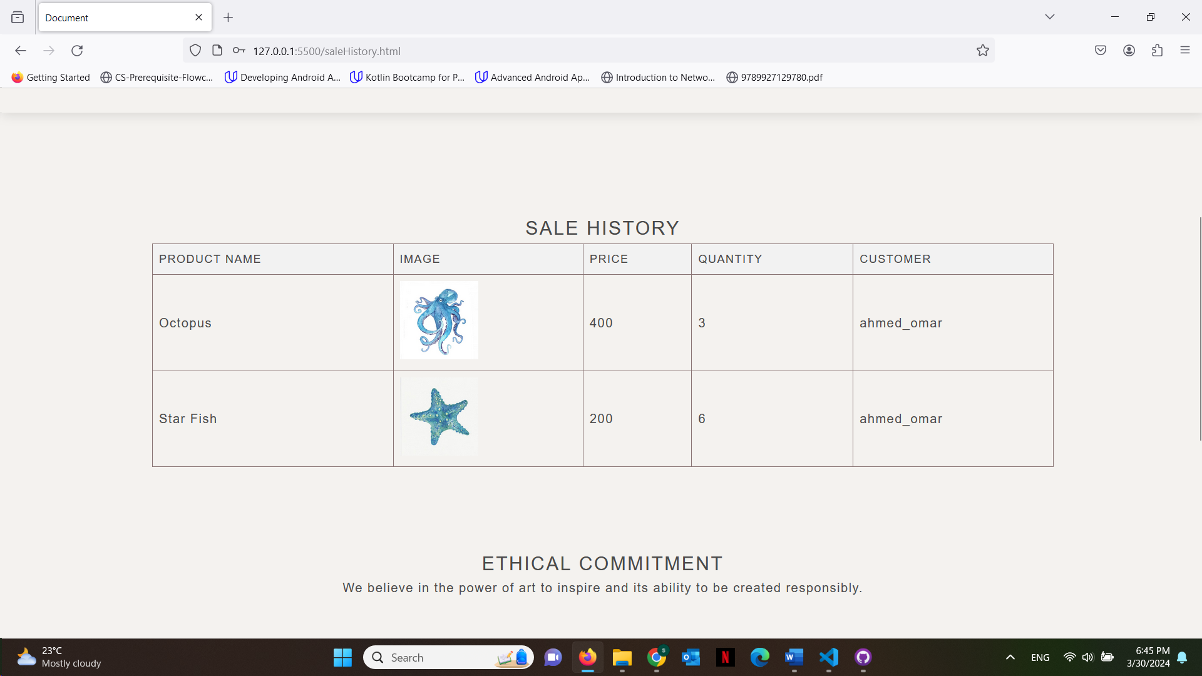

This is what the customer has just bought as we just saw

**When seller goes to sell new art, they can also see what they are currently selling**

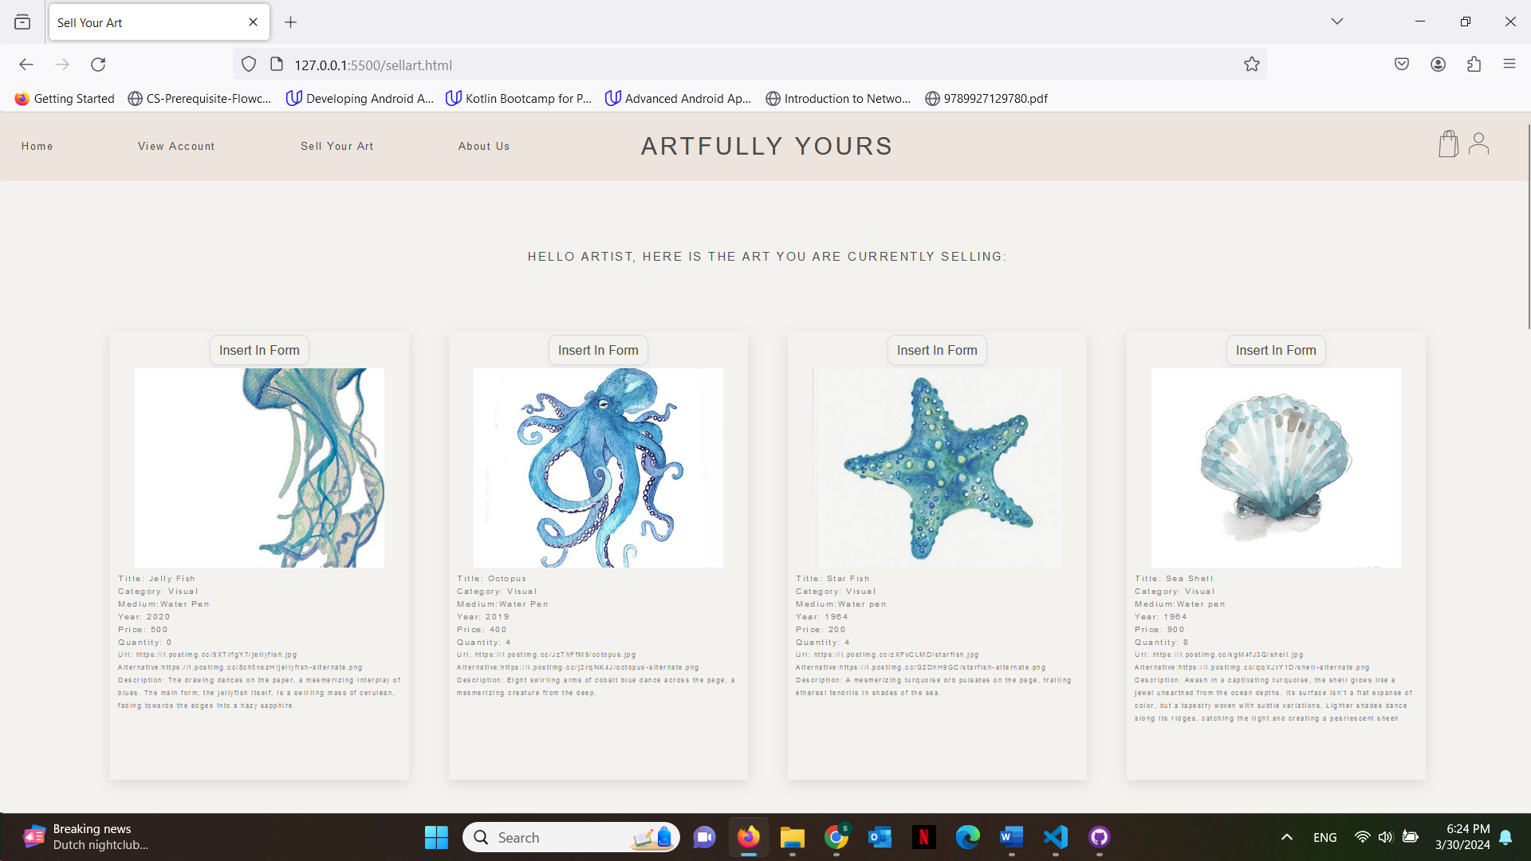

**If they scroll down they can see a form to enter new artwork**

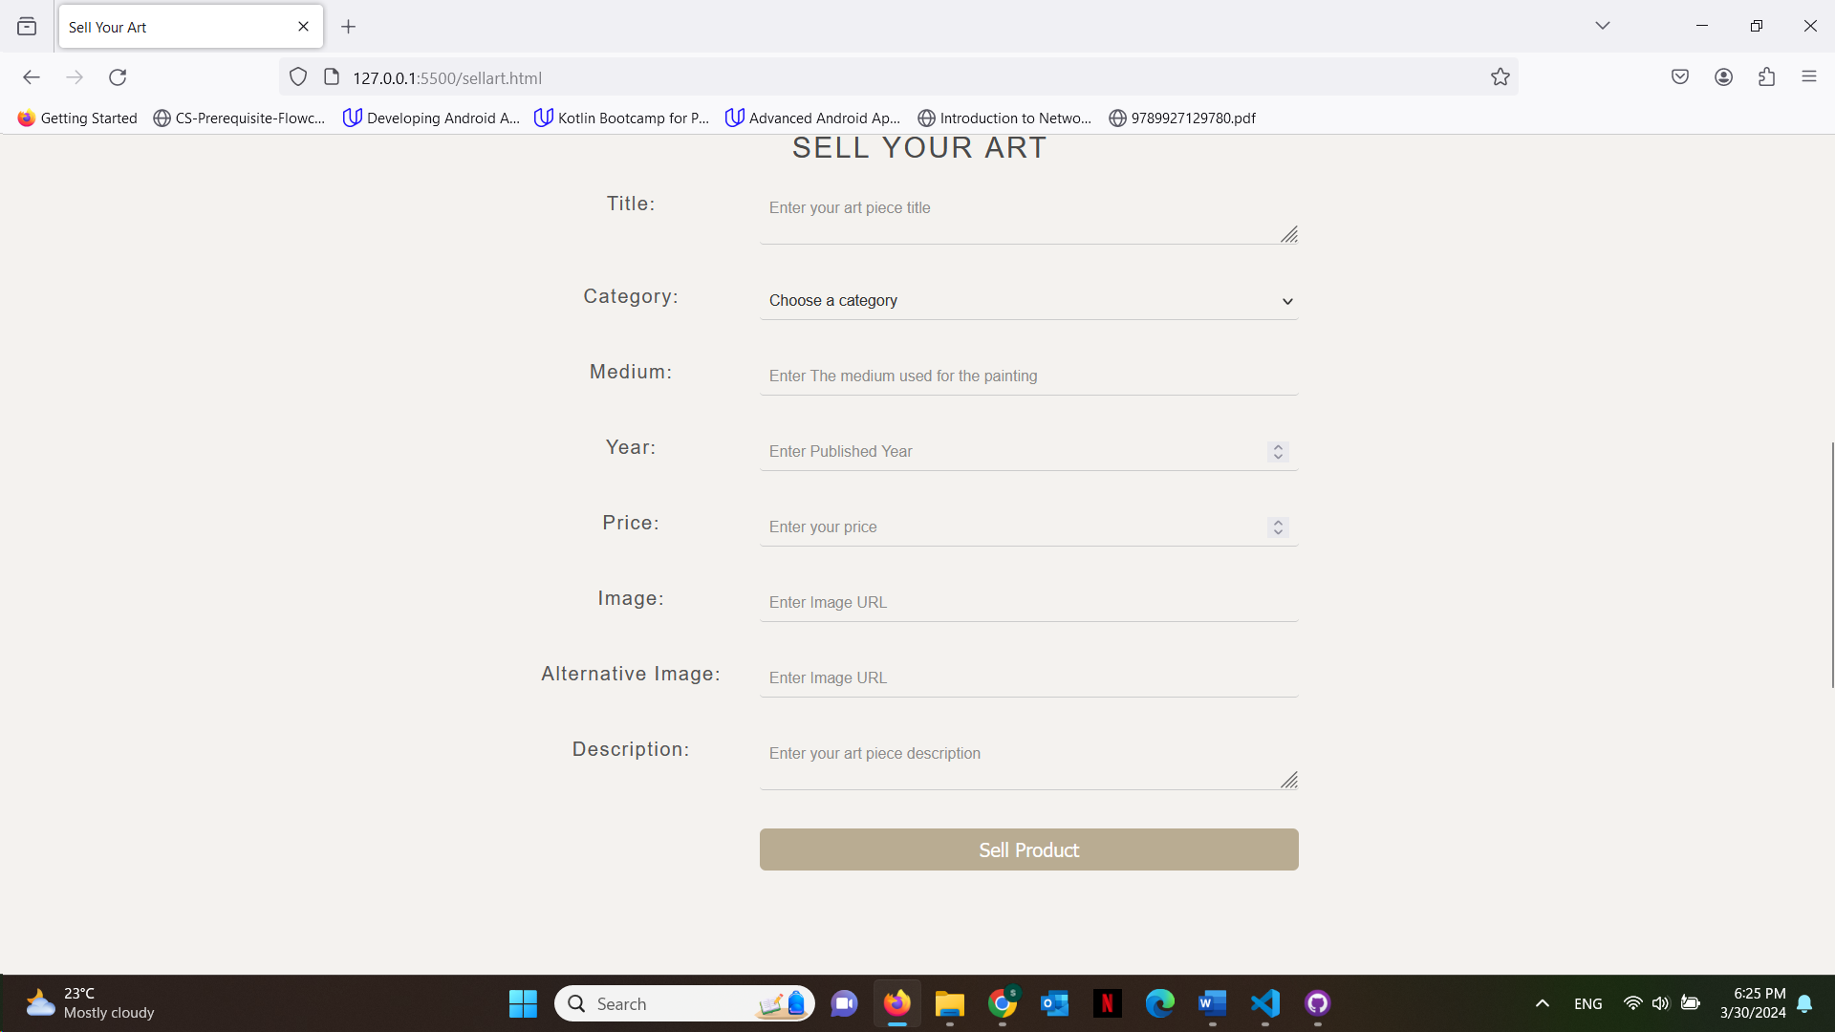**however if they press the buttons insert in form from the artwork on top it will look like this**

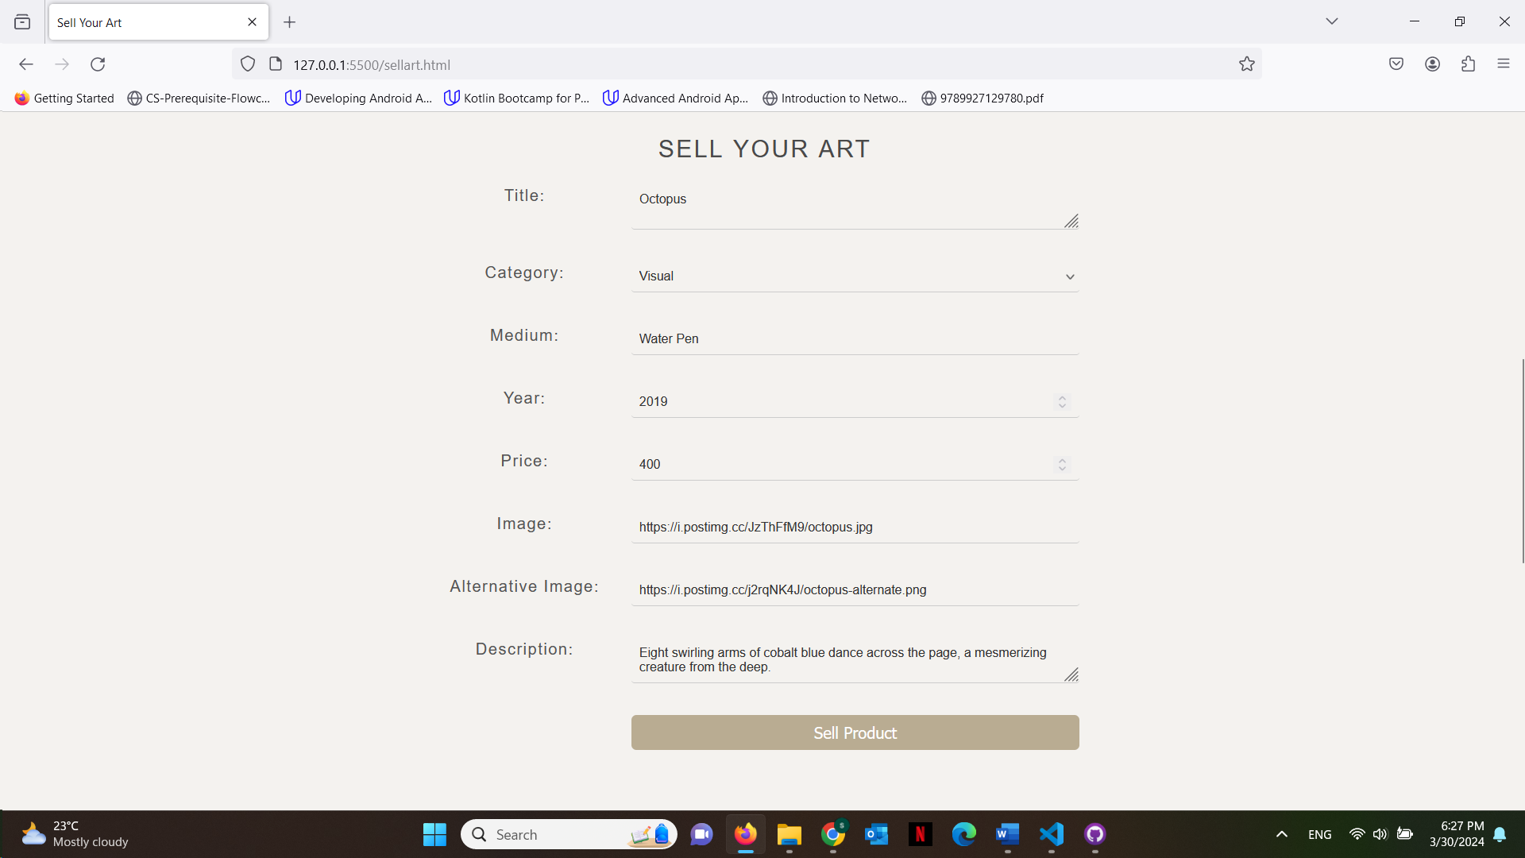**this way the quantity will increase for the artwork that they were already selling.**

**Or we can enter a completely new artwork**

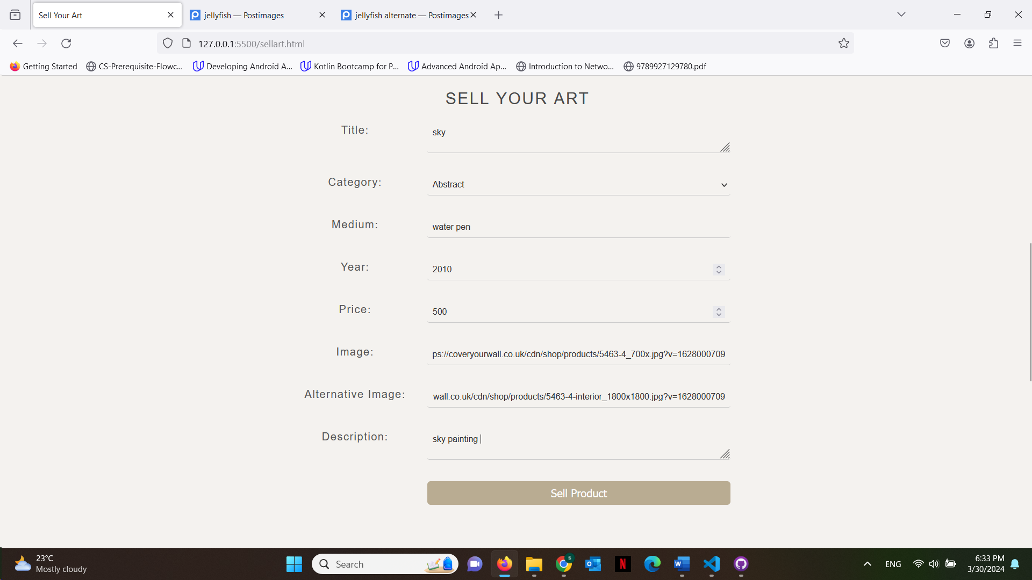

**Now you can see it added to the list in main page**

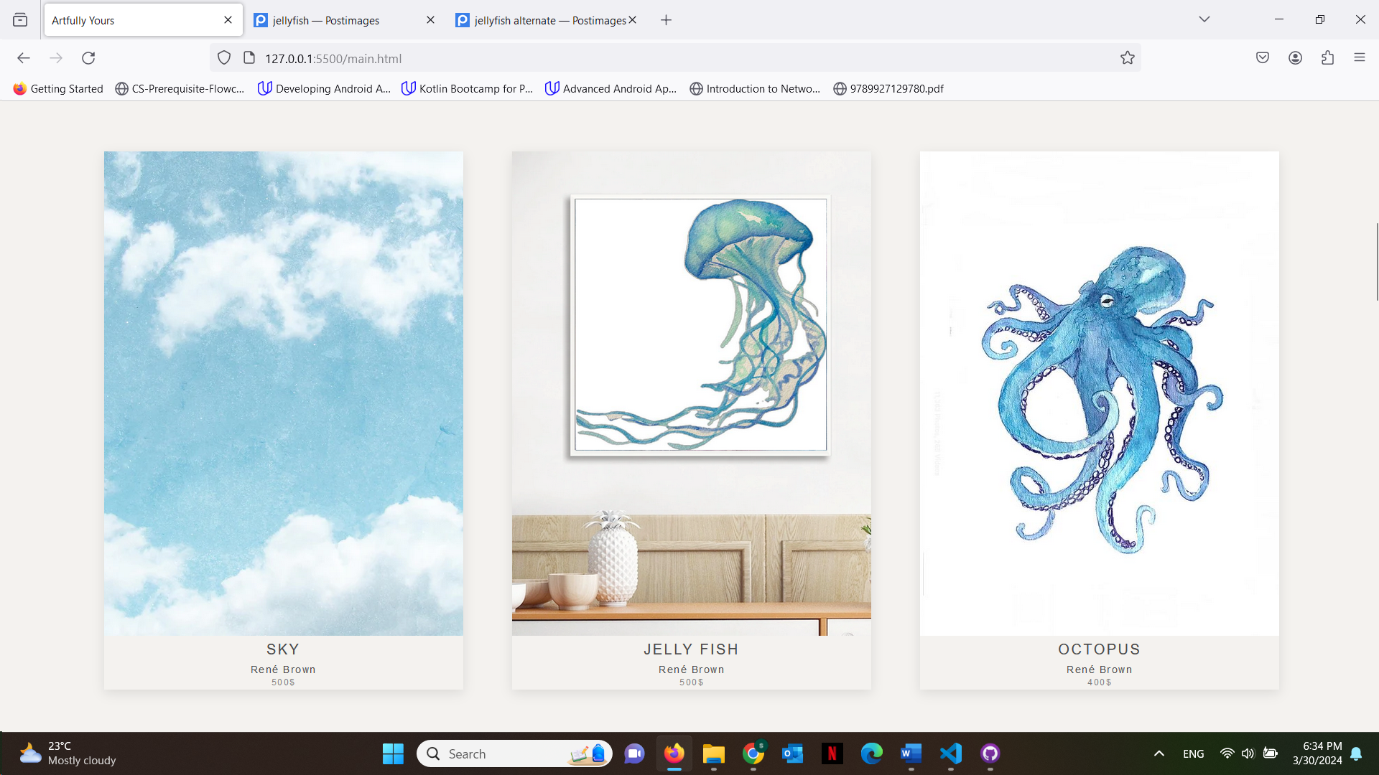

**And in what the seller is currently selling**

